Sports games research
Mechanics to be used from “Game Mechanics” (Adams, E. and Dormans, J., 2012).
Physics: Rigid body, moving, jumping, force.
Social Interaction: Leader board.
Internal Economy: Trophies, scores, time.
Progression: Difficulty?
Winter challenge, video game (Accolade, 1991).
The game lets the player participate on seven winter sports competitions that are competed during winter Olympics. The game can have up to 10 players. The research will look more into the DOS version than the Mega Drive. The DOS game uses directional buttons and one action button.
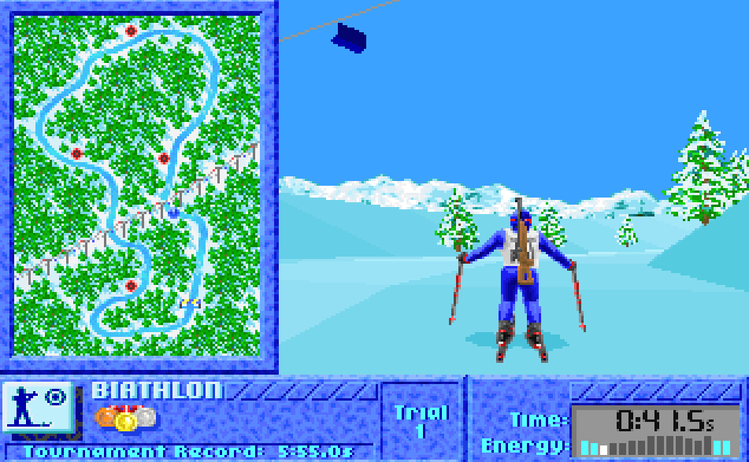
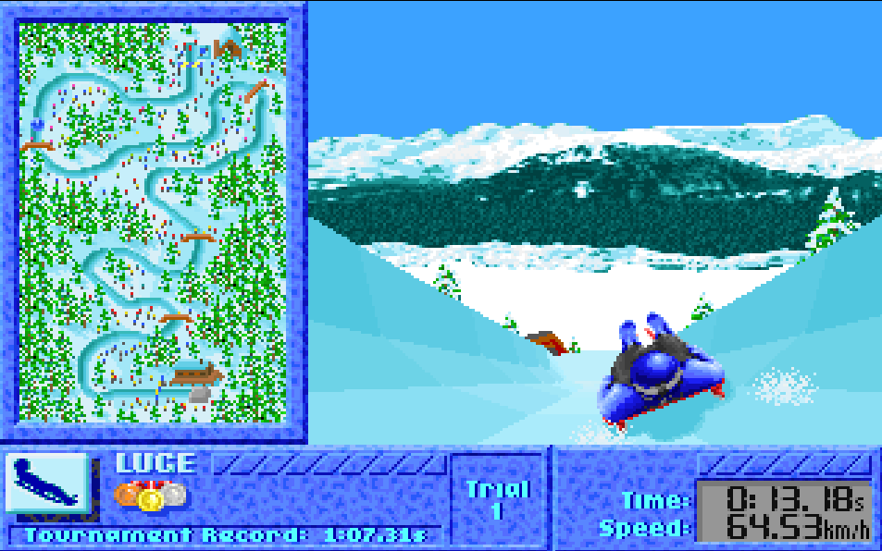
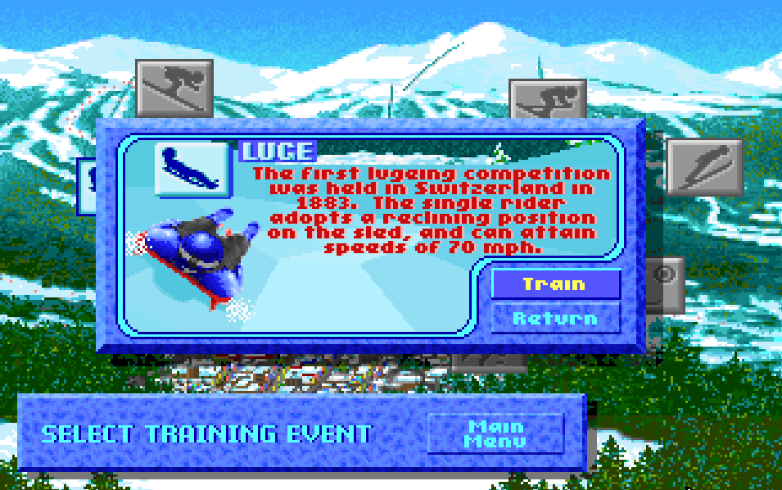
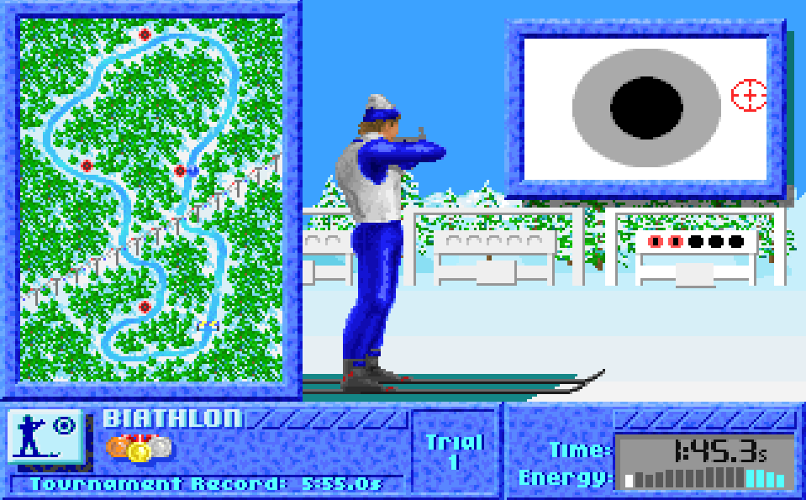
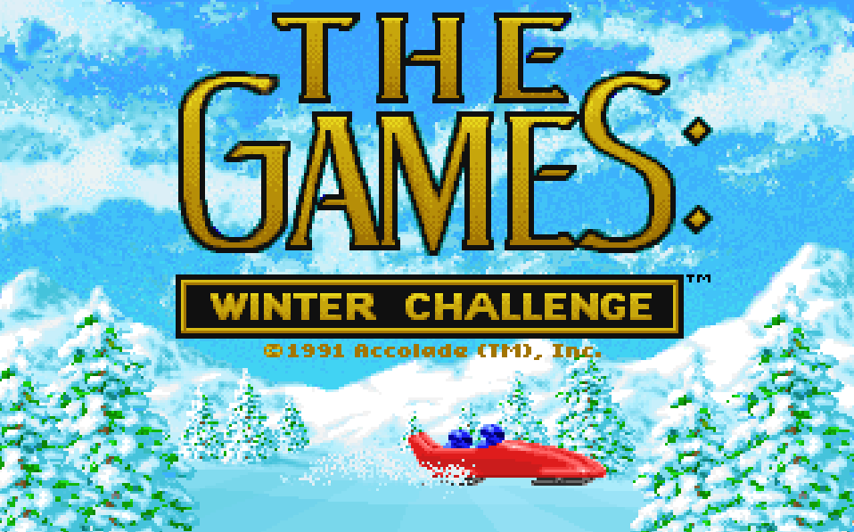
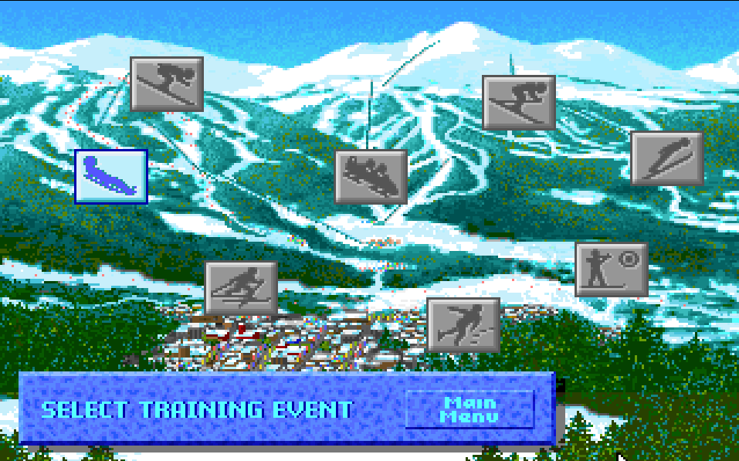
Inspiration used: Map used as a map. Training mode lets you to play in any order but in championship mode you need to complete all sports in order.
https://www.retrogames.cz/play_419-DOS.php
Hyper Sports, Arcade Game (Konami NA: Centuri, 1984)
The two-player game uses three buttons for each player, 2 for running and 1 for action. The player who finishes with the highest scores wins.
Inspiration used:
Speed e.g. meters and the action buttons.
https://www.youtube.com/watch?v=G2fH_fWzhkE
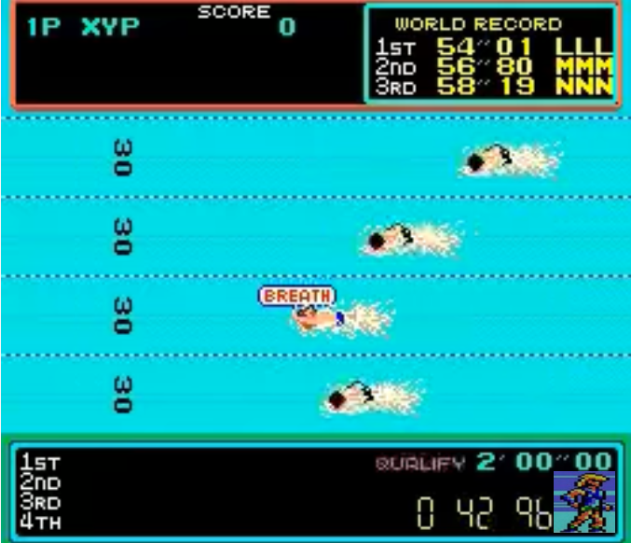
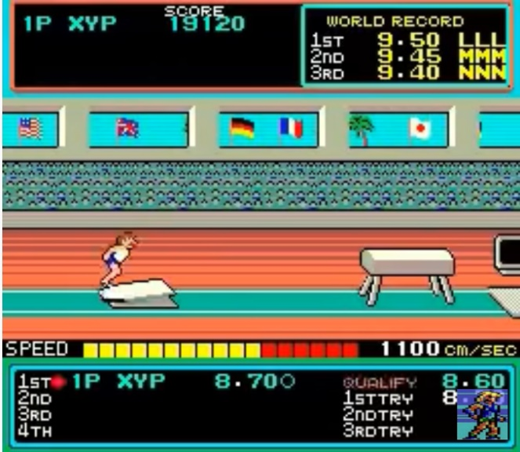
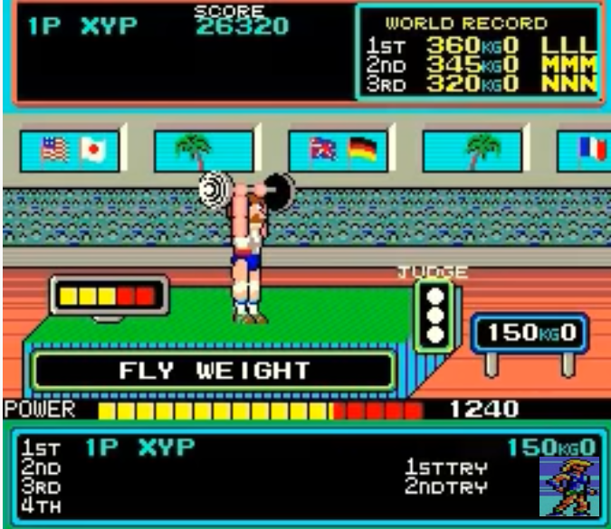

ART STYLE
Pasila, Tv Show (Atte Jarvinen, 2007)
https://areena.yle.fi/1-3822119
